Experiment 6

:Harmonic Oscillator Part II. Physical Pendulum.

Experiment 7

:Waves on a Vibrating String.

Name: Jonathan Goh

UID: 404901382

Date Performed: 5/16/18

Lab Section: Wednesday 8 a.m.

TA: She, Zhenyu

Partner: Daniel Schwartz

Calculating Resonant Frequencies in Oscillating Systems

J.R. Goh1

An oscillating physical pendulum or an oscillating wave on a string can be described by specific equations that have undergone thorough testing by many physicists. Using these sets of equations, we can apply our theoretical knowledge about harmonics to accurately predict and track the frequency of damped and undamped oscillators in our own experiment. The pendulum apparatus employed a damping force by placing two magnets at the bottom of the pendulum’s arch. The magnets create an eddy current that converts the motion of the pendulum into a current, quickly dissipating the energy into heat. An integral analysis tool is the lissajous figure. Under the correct conditions, the figure will look symmetrical, allowing us to predict the resonant frequency in both an oscillating apparatus. Lissajous figures also serve the dual purpose of determine the harmonics and their respective resonant frequencies of a string oscillator. The data recorded is then used to make comparisons between what was observed and what was expected. The result of this experiment is a better understanding about the outcomes of various forces/conditions on oscillations seen in pendulums and fixed strings.

Word Count: 184

1 *Department of Engineering, Henry Samueli School of Engineering and Applied Sciences, University of California Los Angeles.*

1. Introduction

Harmonic motion is a special type of periodic motion that describes the movement of an object that oscillates back and forth about an equilibrium position, and moves along the same path. Harmonic Motion is often times described through use of pendulums and springs, but can actually be seen all around us, for example the vibration of strings on a guitar. Scientists including Robert Hooke, Jean Fourrier, and Galileo all studied harmonic motion, being the first to describe the motion of oscillators through mathematical equations. Simple harmonic motion describes an oscillation in which the force acting upon the body is proportional to the displacement of that body, this represents an ideal undamped oscillation. Damped oscillations on the other hand must take into account external forces that may be acting on the oscillator.

The purpose of this experiment is to investigate the behavior of harmonic motion on a physical pendulum and on a wave of a fixed oscillating string. This experiment allows us to identify the several defined methods for calculating the resonant frequency and verify that it results in the same answer. An integral analysis tool is the lissajous figure. Under the correct conditions, the figure will look symmetrical, allowing us to predict the resonant frequency in both an oscillating apparatus. Lissajous figures also serve the dual purpose of determine the harmonics and their respective resonant frequencies of a string oscillator. In order to better predict their behavior and and gain a better understanding of driven and damped oscillations, we analyzed and compared the effects of changing the driving and damping forces on the oscillations.

Word Count: 264

1. Methods

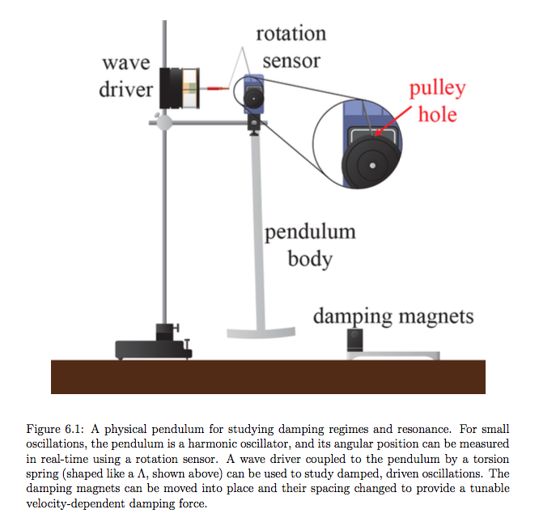

**Figure 6.1: Diagram of Experimental Setup For Experiment 6.**

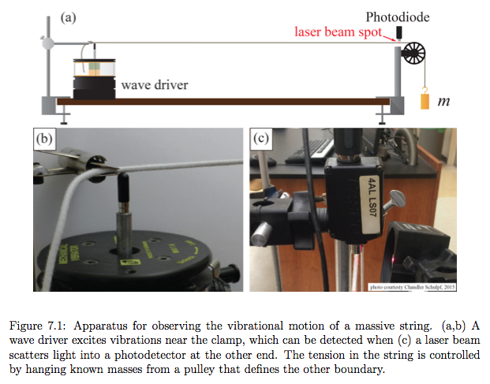

**Figure 7.1: Diagram of Experimental Setup For Experiment 7.**

We begin Experiment 6 by setting up the apparatus depicted in **Figure 6.1**. Set a photogate at a defined position less than one blade length away to make sure that the pendulum is pulled back to a consistent height. This is important to negate as much systematic error as possible. The small angle that is used also allows us to use the small angle approximation in our calculations. Measurements of an undriven, undamped oscillation were taken as a control group of sorts for further trials. Because the rotation sensor changes at intervals of 0.0016 radians and remained unfluctuating at zero while at rest, we took the uncertainty of our angle measurements to be approximately 0.005 radians. Finally, we set the rotation sensor to 25 Hz, measuring the position of the pendulum every 0.04 seconds. Run several trials to and make sure you see that the pendulum continually records a sinusoidal function with similar amplitudes each time.

The next step is to dampen the oscillation by placing magnets at the bottom of the pendulum’s arch; the pendulum must pass between the magnets. The magnets create an eddy current, which converts the motion of the pendulum into a current, quickly dissipating the energy into heat.. Multiple trials of the damped oscillation were recorded and different separation was used between magnets (i.e.10 mm, 20 mm, 30 mm, 40 mm, and 50 mm). An uncertainty of 0.5 mm because it was measured with a meter stick, which has millimeters as its smallest measurement.

We determined that the critical damping distance of the magnets would occur between 10 and 20 mm. At 10 mm, there was a visible overdamping, and at 20 mm, the oscillation was underdamped and continued to oscillate. By comparing the scopes of multiple distances, we determined the critical damping distance to be 9 ± 0.5 mm. This was the magnet distance at which the pendulum returned to equilibrium at the fastest rate.

Next, is the driven oscillation of the pendulum. The driving force is located at the top of the pendulum and is attached to the spring, via hook. A magnet separated at a distance of 23 mm was used because and the pendulum returned the to equilibrium after about seven seconds. A graph was created in capstone, placing voltage on the x axis, and the angle on the y axis. Resonance frequency was determined based on the shape of the graph, a symmetrical ellipse denoted a resonance frequency, while a tilt in a direction denoted a frequency that was either higher or lower than resonance.

Lastly, The amplitude response of the system was recorded at different driven frequencies to pinpoint the resonant frequency as the frequency at which the amplitude of the oscillation was greatest. By finding the frequencies at which the amplitude was the value of the maximum amplitude, we were able to calculate our quality factor by using the width between these two

points. Thus concluding Experiment 6.

We begin Experiment 6 by setting up the apparatus depicted in **Figure 7.1**. Using a balance, accurately measure the mass of our string and the three weights. The wave driver was set up about 1 mm from the clamp, with the tip of the actuator touching the string. The laser was horizontally positioned, and the photodiode was placed directly above the string where the laser had been illuminating it. The photodiode gain was then set to 10.

For the trials used to calculate wave velocity, the laser and photodiode were set next to the pulley. The tension of the system was then measured in order to get the linear mass density of the string for each mass hung from the loop. This was done first by measuring the length from the clamp to the pulley. Then we measured the stretched and unstretched lengths of the string hanging from the pulley in order to get the mass of the hanging string to calculate the tension, and the length used to calculate the linear density.The wave driver was set to 0.25 Hz, so it created a wave every four seconds. The voltage/voltage offset were set to 1 V, the voltage limit was set to 15 V, and the current limit was set to 1.5 A. We then calculated the velocity of the wave using the

equation.

To record data on standing waves, the heaviest mass was used on the experimental apparatus, which created the largest tension and moved the laser and photodiode. A graph was created on capstone to check the light intensity amplitude with respect to the frequency of the wave driver. The max amplitude, represented the resonant frequency. Using lissajous figures we were able to find the exact frequency. When the lissajous figure was as tight and level as it could be, we knew we had reached the resonant frequency. We then repeated this procedure at the 5 other random harmonics.

1. Analysis

**Harmonic Oscillator Part II. Physical Pendulum.**

*Derivations of Equations for Q and for Damping:

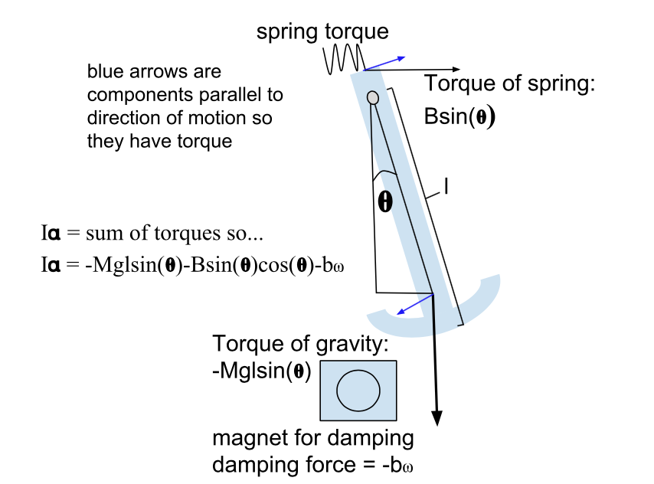

**Figure 6.2.** The diagram above, illustrates the equations of motion that are seen in a damped oscillating pendulum.

Given that:

θ̇

The equation for motion (depicted above):

Since the angle that was used during experimentation was close to , we can make the simplifying assumption that and that :

θ̇

θ̇

θ̇

We can further simplify this equation by substituting the value of

It should be noticed that this is exactly the same equation of motion as we had in Experiment 5 with the replacement , and different definitions of and .

We get that:

The three different regimes of oscillations:

1. Underdamped oscillations are seen when .
2. Overdamped oscillations are seen when .
3. Critically damped oscillations are seen when .

*Plots and Calculations:

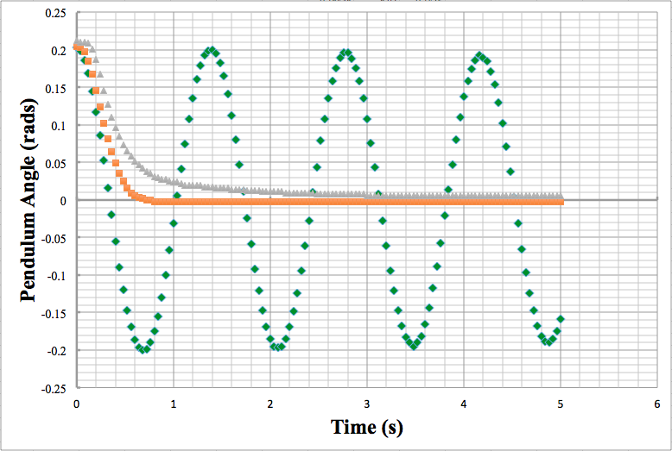

**Figure 6.3: Plot of Underdamped (Undamped), Critically Damped, and Overdamped Oscillations.** The points plotted on the graph represent the angle of the physical pendulum with respect to time.The underdamped pendulum oscillation is illustrated with the green diamonds; there were no damping magnets in use. The critically damped pendulum oscillation is illustrated with the orange squares; the damping magnets were set at a distance of apart from one another. Lastly, the overdamped pendulum oscillation is illustrated with the grey triangles; the damping magnets were set at a distance of apart from one another. The damping effect was created using magnets which convert kinetic energy of the pendulum into heat energy through eddy currents. It can be observed that the critically damped oscillation reaches zero angular displacement the quickest.

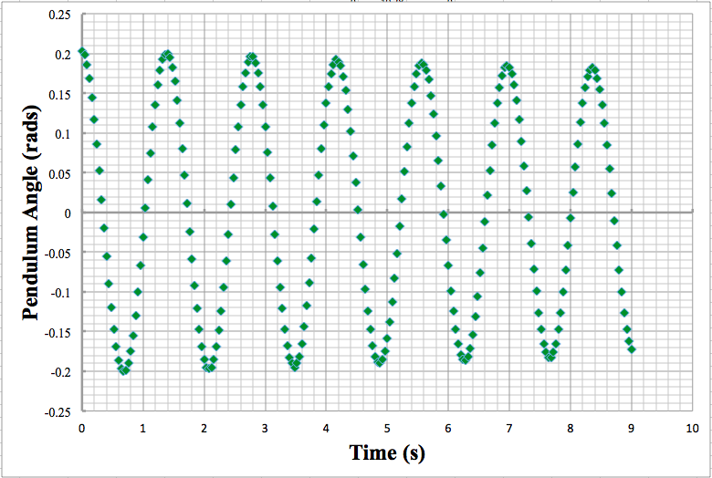

**Figure 6.4: Undamped Oscillation of a Physical Pendulum.** The points plotted on the graph represent the angle of the physical pendulum with respect to time. The rotation sensor was set to record values at a frequency of 25 Hz, which resulted in a measurement of the position every 0.04 seconds with an uncertainty of 0.002 radians.

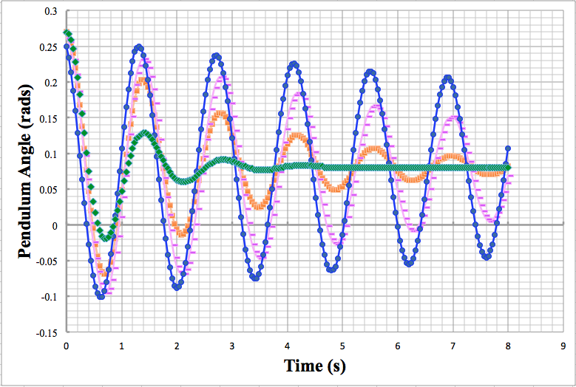

**Figure 6.5: Plot of data for various magnet separations.** The points plotted on the graph represent the angle of the physical pendulum with respect to time. Data was collected for five oscillations of various separations. The blue data represents of spacing between magnets. The pink data represents of spacing between magnets. The orange data represents of spacing between magnets. The green data represents of spacing between magnets.

Based on **Figure 6.3: Plot of Underdamped (Undamped), Critically Damped, and Overdamped Oscillations.**

1. The undamped/underdamped motion was seen when there were no damping magnets.
2. The critically damped oscillation was observed when there was a separation ofof spacing between the magnets.
3. The overdamped motion was observed when there was a separation that smaller than between the magnets.

Calculating undamped oscillation frequency using extrema method based on **Figure 6.4**:

To perform this method we zoom into each maximum to find the time at each position. Using the time at the first and the last extrema we can calculate the period of oscillation for the harmonic motion.

Time at the 6th extrema: seconds

Time at the 1st extrema: seconds

Calculating the period of the oscillation:

Calculating uncertainty of period using the propagation of uncertainties formula (+/-):

Calculating the frequency of the oscillation:

Calculating uncertainty of frequency using the propagation of uncertainties formula (:

or

Therefore the calculated value of :

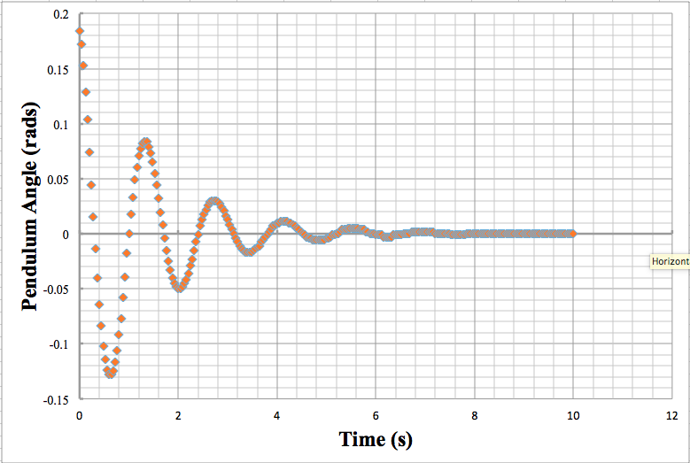

**Figure 6.6: Plot of Damped Driven Oscillation.** The points plotted on the graph represent the angle of the physical pendulum with respect to time. This underdamped, driven, motion was observed when there was a separation that smaller than between the magnets. It took approximately 8 seconds worth of oscillating for the pendulum to reach its equilibrium.

|  |  |  |  |
| --- | --- | --- | --- |
| **Extrema Number** | **Time (seconds)** | **Maximum Angle (rads), Amplitude** | **Damping Constant** |
| 1 | 1.36 | 0.084 | N/A |
| 2 | 2.76 | 0.03 | 1.35972 |
| 3 | 4.20 | 0.011 | 1.43526 |
| 4 | 5.44 | 0.005 | 1.57268 |
|  |  | Average | 1.45589 |
|  |  | Std. Dev. (Uncertainty) | 0.09 |

**Table 6.1: Data required to calculate damping time in the damped, driven, oscillation.** To get the value of we took the average of these values to find the best value and used their standard deviation to find the uncertainty. The value of τ was calculated: .

Calculating the Resonance Frequency of driven oscillations.

Driven Oscillations must take into account another term, for drive frequency:

θ̇

The expression to calculate resonant frequency is given by the equation:

Given that: (is amplitude, is period, and is damping constant)

Therefore:

Average Damping Constant:

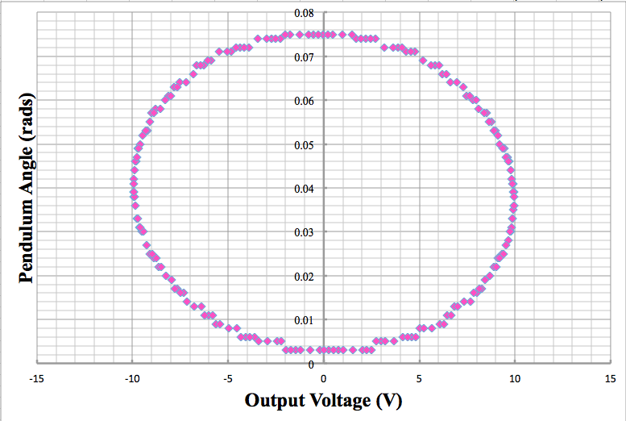

**Figure 6.7(a): Lissajous Figure with driving frequency equal to the resonant frequency.** A driving frequency of 0.72 was used to create the Lissajous figure depicted above. The plot, illustrates a symmetric ellipse. The uncertainty was determined to be approximately , this is due to the fact that there seemed to be a noticeable difference in the graph at any range greater or lesser than that. This is a good method to approximate resonant frequency without having to do heavy computation.

Therefore:

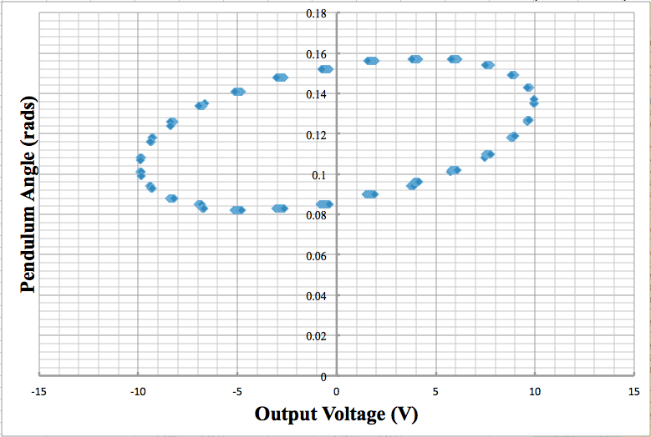

**Figure 6.7(b): Lissajous figure with driving frequency less than the resonant frequency.** A driving frequency of 0.72 was used to create the Lissajous figure depicted above. The plot, illustrates an ellipse that is angled with a negative trend/slope.

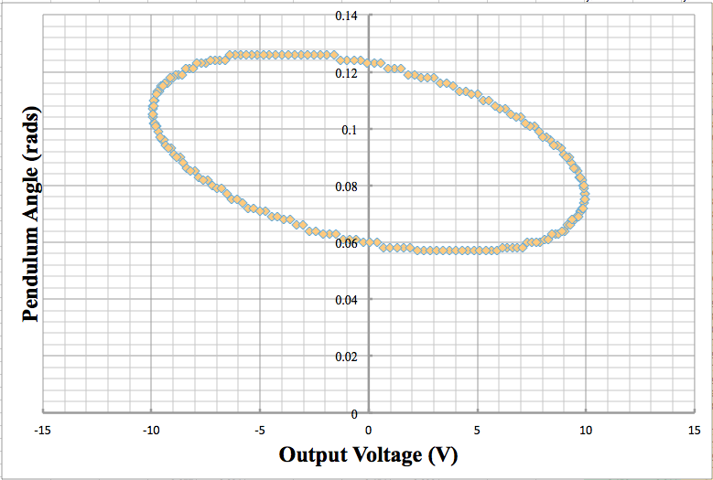

**Figure 6.7(c): Lissajous figure with driving frequency greater than the resonant frequency.**

A driving frequency of 0.74 was used to create the Lissajous figure depicted above. The plot, illustrates an ellipse that is angled with a positive trend/slope.

Calculating from derived equations.

We know that :

Substituting in our known values:

Calculating Uncertainty (Using above uncertainties):

*Calculated value of :

Using the relationship for damped oscillations (i.e. , , ), we can make some general conclusions:

The value of the undamped scenario returned a value of , which shows a very minimal difference from the value of . In fact, there is only a 0.03 difference between the two numbers.

Due to the extremely close values of numbers that should be more polarizing, we can make the conclusion that our calculated Q is most likely inaccurate.

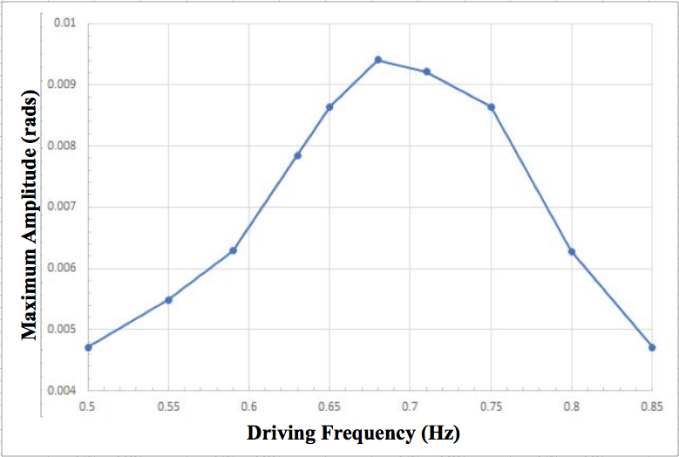

**Figure 6.8: Measured oscillation amplitude spectrum of a damped, driven oscillator.** The points plotted on the graph represent the Maximum Amplitude of the oscillator with respect to a given Frequency. The plot illustrates the Lorentzian shape of the resonance. The max amplitude is achieved when the resonant frequency matches the driven frequency

**Calculating of the oscillation using :**

Using the derived equation, this is another method to solve for of our oscillation:

is calculated by calculating the width of the plot when amplitude is equal to times the resonant amplitude. The two positions where this occur are at:

and

and

Therefore,

Substituting these known values we get:

Lastly, we can calculate using the equation that relates and :

and

or

=

|  |  |
| --- | --- |
| **Method** | **Calculated value** |
| #1) |  |
| #2) |  |
| #3) |  |

**Table 6.2: Final comparison of calculated values.** It is apparent that there is a difference between the 3 methods that were used to calculate the values. This is most likely attributed to the fact that there was a small angle that was used to approximate measurements. Another factor could be the uncertainty that came from determining the resonance widths.

**Waves on a Vibrating String.**

*Derivations of Equations for Q and for Damping:

To calculate Tension Force on the the string:

mass of attached mass

mass of dangling portion of the rope

Hanging Rope Mass:

Using proportions to equate the fraction of length to the fraction of weight.

Given a string with tension and mass density , we can calculate for the wave speed:

To calculate linear mass density, we are given:

|  |  |  |  |  |  |
| --- | --- | --- | --- | --- | --- |
| **Hanging Mass ,(kg)** | **Dangling Rope Mass, (kg)** | **Dangling Portion of Rope (m)** | **Tension Force (N)** | **Linear Mass Density, (kg/m)** | **Velocity, (m/s)** |
| 0.0998 | 0.0037 ± 0.0005 | 0.556 | 1.0143 ± 0.0002 | 0.0066 ± 0.0002 | 12.4 ± 0.4 |
|
| 0.1998 | 0.0040 ± 0.0005 | 0.603 | 1.9972 ± 0.0002 | 0.0063 ± 0.0002 | 17.8 ± 0.4 |
|
| 0.3996 | 0.0044 ± 0.0005 | 0.66 | 3.9592 ± 0.0003 | 0.0059 ± 0.0002 | 25.9 ± 0.7 |
|

**Table 7.1: Manipulated Table of Data.**

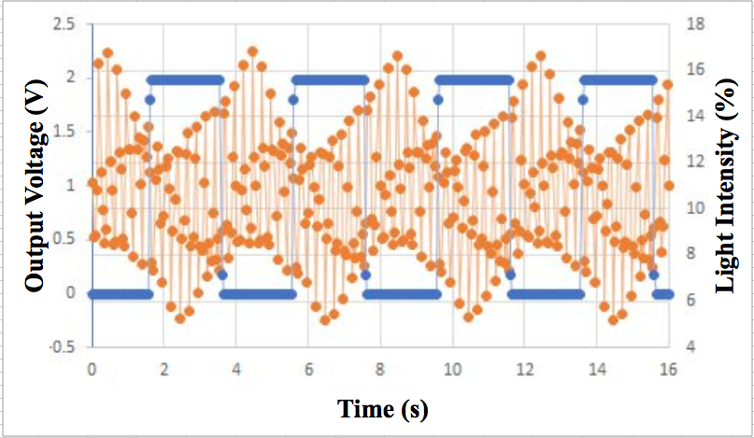

**Figure 7.2(a): Plot to Calculate Wave Velocity of Dangling Mass 1.** The orange points plotted on the graph represent the Light Intensity percentage with respect to time of the oscillator with respect to a given Frequency. In addition, Output Voltage with respect to time is also plotted, and is demarcated by a blue dot. The plot illustrates a recurring pattern of points, which is indicative of the movement pattern of the oscillating string. In order to calculate velocity, we use the equation: and . represents the time length of the string from pulley to clamp, and represents the change in time between two maxima from light intensity. The length of the string to the pulley was recorded as The average change in time between peaks was calculated to be approximately .

Calculations:

Uncertainties calculated using this formula:

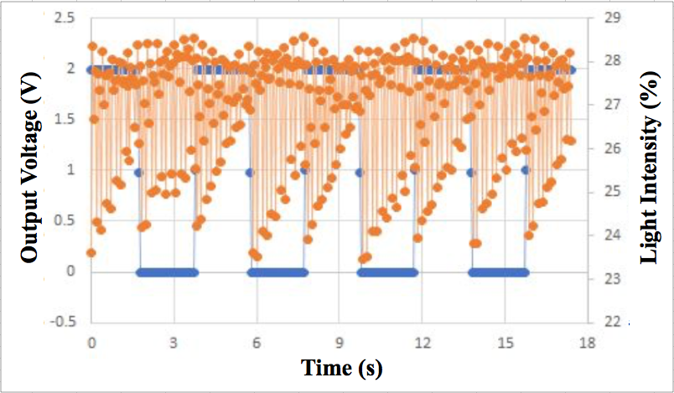

**Figure 7.2(b): Plot to Calculate Wave Velocity of Dangling Mass 2.** The orange points plotted on the graph represent the Light Intensity percentage with respect to time of the oscillator with respect to a given Frequency. In addition, Output Voltage with respect to time is also plotted, and is demarcated by a blue dot. The plot illustrates a recurring pattern of points, which is indicative of the movement pattern of the oscillating string. In order to calculate velocity, we use the equation: and . represents the time length of the string from pulley to clamp, and represents the change in time between two maxima from light intensity. The length of the string to the pulley was recorded as The average change in time between peaks was calculated to be approximately .

Calculations:

Uncertainties calculated using this formula:

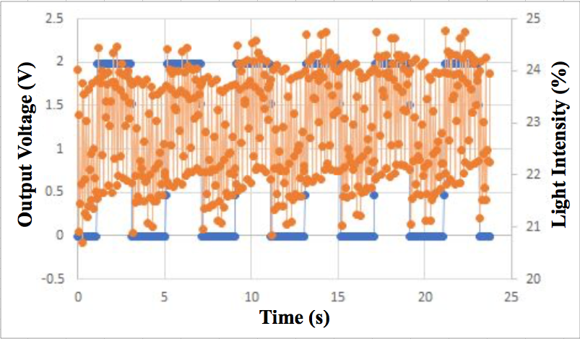

**Figure 7.2(c): Plot to Calculate Wave Velocity of Dangling Mass 3.** The orange points plotted on the graph represent the Light Intensity percentage with respect to time of the oscillator with respect to a given Frequency. In addition, Output Voltage with respect to time is also plotted, and is demarcated by a blue dot. The plot illustrates a recurring pattern of points, which is indicative of the movement pattern of the oscillating string. In order to calculate velocity, we use the equation: and . represents the time length of the string from pulley to clamp, and represents the change in time between two maxima from light intensity. The length of the string to the pulley was recorded as The average change in time between peaks was calculated to be approximately .

Calculations:

Uncertainties calculated using this formula:

*Predicting the Frequency of the nth Normal Mode:

To Calculate the Predicted Frequency we use the given equation:

This equation can be further simplified given that:

Substitute into the equation to get:

For this part of the experiment we utilized the **heaviest** dangling mass for data collection:

Therefore, we can plug in the period from **Figure 7.2(c)** to predict our values:

|  |  |  |
| --- | --- | --- |
| **Harmonic** | **Observed Frequency** | **Predicted Frequency** |
| 1 |  |  |
| 2 |  |  |
| 3 |  |  |
| 4 |  |  |
| 5 |  |  |

**Table 7.2: Compare the Predicted Frequency Against the Observed Frequency.** The predicted frequency was approximated by using the formula . The values are not the same, however, they are very similar. This could be due to a lack of precision, or maybe due to error with calculating the original velocity.

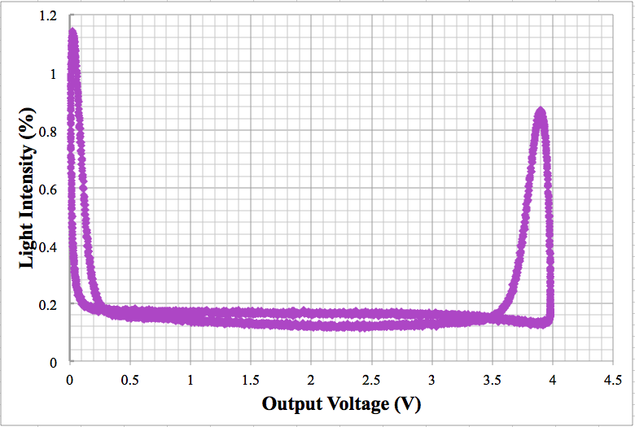

**Figure 7.3(a): 1st Harmonic Lissajous Plot of Resonant Frequency.** By observing the symmetry of the graph, we received a resonant frequency of about . The uncertainty was found by seeing how much the frequency could change without a noticeable shift in the graph. It can also be observed that the plot is symmetrical, which means that it is close to the actual resonant frequency.

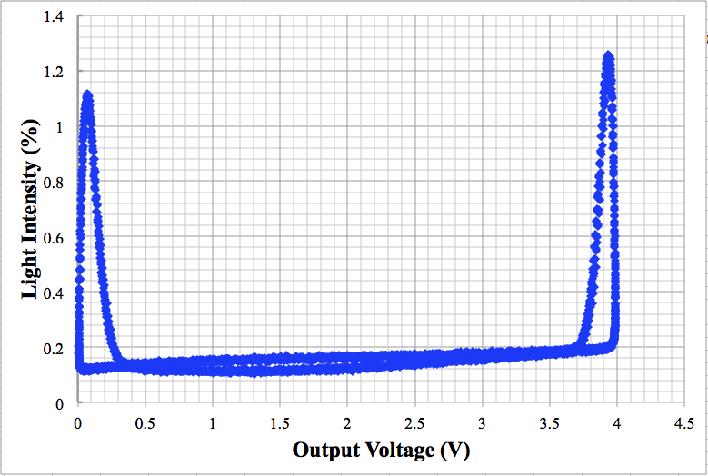

**Figure 7.3(b): 2nd Harmonic Lissajous Plot of Resonant Frequency.** By observing the symmetry of the graph, we received a resonant frequency of about . The uncertainty was found by seeing how much the frequency could change without a noticeable shift in the graph. It can also be observed that the plot is symmetrical, which means that it is close to the actual resonant frequency.

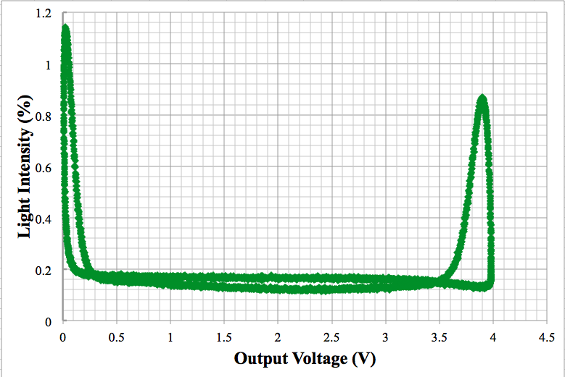

**Figure 7.3(c): 3rd Harmonic Lissajous Plot of Resonant Frequency.** By observing the symmetry of the graph, we received a resonant frequency of about . The uncertainty was found by seeing how much the frequency could change without a noticeable shift in the graph. It can also be observed that the plot is symmetrical, which means that it is close to the actual resonant frequency.

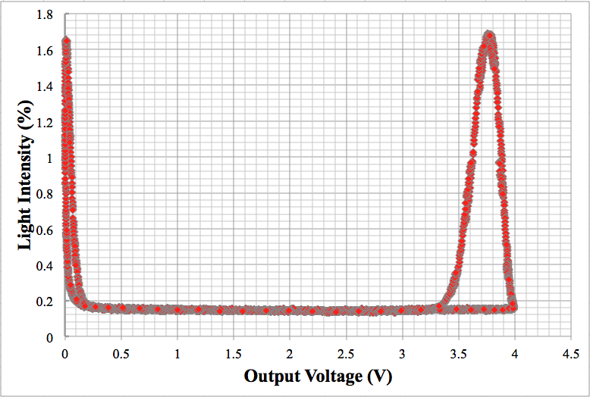

**Figure 7.3(d): 4th Harmonic Lissajous Plot of Resonant Frequency.** By observing the symmetry of the graph, we received a resonant frequency of about . The uncertainty was found by seeing how much the frequency could change without a noticeable shift in the graph. It can also be observed that the plot is symmetrical, which means that it is close to the actual resonant frequency.

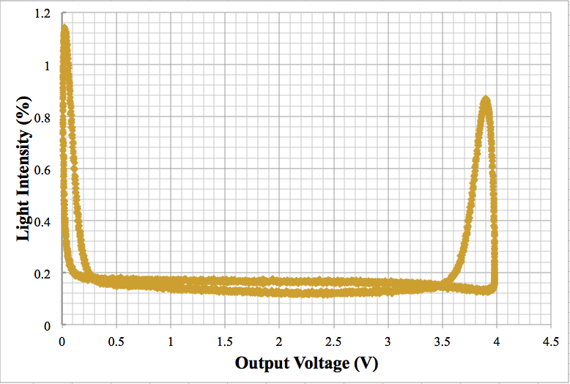

**Figure 7.3(e): 5th Harmonic Lissajous Plot of Resonant Frequency.** By observing the symmetry of the graph, we received a resonant frequency of about . The uncertainty was found by seeing how much the frequency could change without a noticeable shift in the graph. It can also be observed that the plot is symmetrical, which means that it is close to the actual resonant frequency.

1. Conclusion

The purpose of this experiment was to investigate the behavior of harmonic motion on a physical pendulum and on a wave of an oscillating string. Furthermore, this experiment allowed us to identify the several defined methods for calculating the resonant frequency and verify that it resulted in the same answer. In order to better predict their behavior and and gain a better understanding of driven and damped oscillations, we analyzed and compared the effects of changing the driving and damping forces on the oscillations.

Experiment 6 had interesting results after the data was manipulated and analyzed. The observed results of my trials with the physical pendulum were consistent with the expected results. However, when solving for the unknown value of , my calculations were not very consistent. From the three defined methods of calculation, I received the values , , and . The results are very haphazard, and confounded me. A large source of error comes from the fact that the physical pendulum experiences more than just the perfect (planar) forces that we would hope to see in the experiment. Instead, there is movement in all dimensions of the swing of the pendulum, which accounts for some loss of energy due to the fact that not all of its motion is directed in the intended path. Similarly, vibrations of the pendulum were noticeable as it completed its oscillations.

In experiment 7, the data that was collected showed immense noise. The cause of this noise comes from the fact that the oscillations of the string are not completely restricted to a vertical motion, instead, some horizontal movement is captured when data is being recorded. Another reason for the chaotic noise is due to the sensors that were used, which are only accurate to a certain extent. On the other hand, the wave speed velocities were fairly accurate to what was predicted. As can be seen with Lissajous figures, the predicted frequency for the nth nodes was extremely similar to the actual observed values that were collected from playing around with the graphs. In order to have an accurate predicted frequency there must have been an accurate value for the wave velocity.

Despite some of our compared data not matching well, our oscillations in both the pendulum and string responded as expected. Through this lab, we were able to predict how changes in the system would affect the oscillation.

Word Count: 406

1. Bibliography

Campbell, W. C. et al. Physics 4AL: Mechanics Lab Manual (ver. August 31, 2017). (Univ. California Los Angeles, Los Angeles, California).

Young, Hugh D, Roger A. Freedman, A L. Ford, and Francis W. Sears. Sears and Zemansky's University Physics: With Modern Physics. San Francisco: Pearson Addison Wesley, 2004. Print.